**hRemaining**

**Done perfectly**

**● The CASE STUDIES which are under consideration**

○ Hotel/Restaurant management system

○ Railway reservation system

○ Tours and Travels booking system

○ Online banking system

○ Online inventory management system

○ Online Movie Booking System

○ Library Management System

○ Course Scheduling System

1. **On Hotel/restaurant management system**, write SRS in IEEE Format

[srs-hotel-management-system-ok.pdf](https://dipeshagrawal.files.wordpress.com/2018/07/srs-hotel-management-system-ok.pdf)

<https://www.studocu.com/in/document/delhi-technological-university/computer-science/railway-reservation-system/11957519>

2. Mention design **of Railway reservation system** by considering Cohesion & Coupling

https://www.studocu.com/in/document/delhi-technological-university/computer-science/railway-reservation-system/11957519

3. **On tours and travels booking system create any two** architectural Style

<https://medium.com/tuimm/architecture-patterns-for-booking-management-platform-53499c1e815e>

4. Design of white Box Testing (**only on Course Scheduling System**)

5. **Perform** Black box testing **On online banking system**

[**https://artoftesting.com/banking-application-testing**](https://artoftesting.com/banking-application-testing)

6. Perform Risk Analysis **On Online inventory management system**

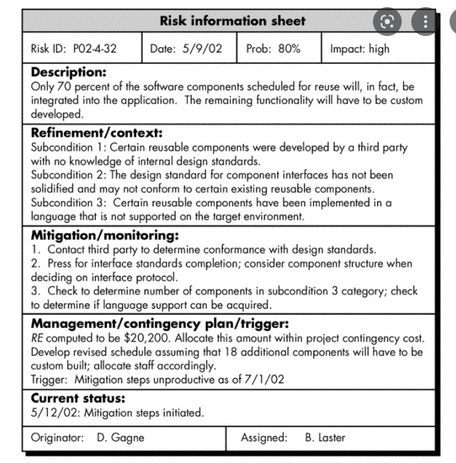[**https://www.researchgate.net/publication/344840804_Risk_assessment_model_in_inventory_management_using_the_AHP_method**](https://www.researchgate.net/publication/344840804_Risk_assessment_model_in_inventory_management_using_the_AHP_method)

7. Create Quality Assurance plan **for Online Movie Booking System** 8. CALCULATE FUNCTION POINT **for Course Scheduling System,**

9. **On the Hotel/restaurant management system,** create COCOMO MODEL ESTIMATION

<https://www.interviewbit.com/blog/cocomo-model-in-software-engineering/#:~:text=EAF%20%3D%20It%20is%20an%20Effort,ideal%2C%20the%20value%20is%201>.

10. **On Library Management System,** Use JIRA TOOL(Scrum Implementation)

11. **On Tours and travels booking system,** Use JIRA TOOL(Kanban Implementation) 12. **Do version controlling for Online banking system (** GIT HUB & JIRA )

<https://medium.com/@fredrick.adegoke/version-control-systems-source-code-banking-efcbb9272aee>

13. Set up a procedure for change control in course scheduling system

<https://www.indeed.com/career-advice/career-development/change-control-procedure>

14. Set up a procedure for change control in library management system

15. Set up a procedure for change control in ticket booking system

16. Write user stories, epics and at least two Sprints on Course Scheduling System

17. Write user stories, epics and at least two Sprints on online banking system

18. Use equivalence partitioning testing strategy for executing the test cases on Course Scheduling System <https://www.javatpoint.com/equivalence-partitioning-technique-in-black-box-testing>

19. Use equivalence partitioning testing strategy for executing the test cases on railway reservation system

20. Write a program in JAVA for calculator and hence show its testing[ Black Box And White Box]

21. Develop a design document for any Mini Project undergone [Any sem SE/TE]

22. Development of DFD and ER Diagram for any Mini Project undergone [Any sem SE/TE]

<https://meeraacademy.com/dfd-diagram-for-online-food-ordering-system/>

<https://meeraacademy.com/e-r-diagram-for-online-food-ordering-system/>

23. Implementation of Course Scheduling System using Data Centered Architecture style

24. Write the program in **Java OR C OR C++** which exhibits **Functional cohesion**

import java.util.*;

import java.util.ArrayList;

public class Main{

static void sales_tax(String product, ArrayList<String> arr,Dictionary dict)

{

double sales_tax;

try{

int price=Integer.parseInt(dict.get("Snacks").toString());

if(arr.contains(product))

{

sales_tax=0;

//System.out.println("The sales tax of "+product+" is Rs. "+sales_tax );

}

else{

if(price<1000)

sales_tax= price*0.2;

else

sales_tax= price*0.35;

}

System.out.println("The sales tax of "+product+" is Rs. "+sales_tax );

}

catch(NullPointerException e){

System.out.println("Caught excp");

}

}

public static void main(String[] args) {

ArrayList<String> arr = new ArrayList<String>(3);

arr.add("milk");

arr.add("flowers");

arr.add("fruits");

System.out.println("The array you entered is "+arr);

Dictionary<String,Integer> dict = new Hashtable<String,Integer>();

dict.put("Smartphones", 20000);

dict.put("Snacks", 20);

dict.put("Chocolates", 100);

sales_tax("Snacks",arr,dict);

System.out.println(dict.get("Snacks"));

}

}

25. Write the program in **Java OR C OR C++** which exhibits **Sequential cohesion**

26. Write the program in **Java OR C OR C++** which exhibits **Communicational cohesion**

public class DocsRepository {

public Doc findById(DocId id) {

//method's body

return doc;

}

public Doc save(Doc document) {

//method's body

return doc;

}

public Doc findByIdAndType(DocId id, DocType type) {

//method's body

return doc;

}

public List<Doc> findAll() {

//method's body

return docsList;

}

}

27. Write the program in **Java OR C OR C++** which exhibits **Procedural cohesion**

28. Write the program in **Java OR C OR C++** which exhibits **Temporal cohesion**

29. Write the program in **Java OR C OR C++** which exhibits **Logical cohesion**

30. Write the program in **Java OR C OR C++** which exhibits **Coincidental cohesion**

31. Write the program in **Java OR C OR C++** which exhibits **Content coupling**

32. Write the program in **Java OR C OR C++** which exhibits **Common coupling**

33. Write the program in **Java OR C OR C++** which exhibits **External coupling**

34. Write the program in **Java OR C OR C++** which exhibits **Control coupling** 35. Write the program in **Java OR C OR C++** which exhibits **Stamp** coupling 36. Write the program in **Java OR C OR C++** which exhibits **Data** coupling

For data and control coupling

<https://www.philadelphia.edu.jo/academics/wbanimustafa/uploads/TN%20Data_and_Control_Coupling_v1.0.pdf>

**37. Re-evaluation of Course Scheduling System**

***- VIVA WilL BE BASED ON THE ENTIRE SYLLABUS AS WELL AS ON THE ASSIGNED PRACTICAL EXAM QUESTION***

***- EXAM IS OF 25 MARKS DURATION 2 HRS FOR EACH STUDENT***